| TMS Required Browser Settings

Summary
TMS OnSite/OnLine requires certain settings to be configured on both the end-user’s PC and on an organization’s network. This document will outline settings required for full functionality within TMS, including:
- Internet Explorer Options
- .NET Framework
- Anti-Virus Active Script Scanning
- Network Proxy/Firewall Settings (TMS OnLine)
NOTE: Depending upon your organization’s security settings and the permissions granted to your account(s), you may need assistance from your IT/IS department to complete some or all of the steps in this guide.

Internet Explorer Options
To run properly, TMS requires explicit permission from Internet Explorer on each computer accessing the application. The first step in granting these permissions is to open Internet Options, located under the Settings menu (“gear” icon) located in the upper right-hand corner of Internet Explorer.
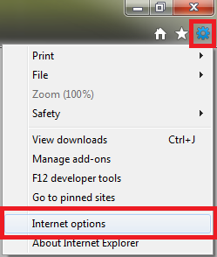

Once in the Internet Options window, navigate to the Privacy tab and ensure that Pop-up Blocker is turned off. Pop-up Blocker can interfere with TMS reports, which typically display as a PDF file within their own browser window. You must also choose a privacy setting that allows cookies from TMS, though the default setting of Medium is sufficient.
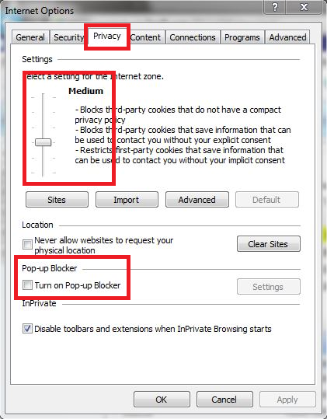
For the next step, you’ll need to know the web address of your TMS application server. TMS OnLine users can always use *.tmsonline.com, as the asterisk will fill in for their organization’s specific domain. The server addresses for TMS OnSite users will vary between organizations, but your IT/IS department or an existing TMS user should be able to provide the address to you.

Once you have the address for your TMS application server, navigate to the Security tab and click on Trusted Sites. Next, click on the Sites button to add TMS as a Trusted Site.
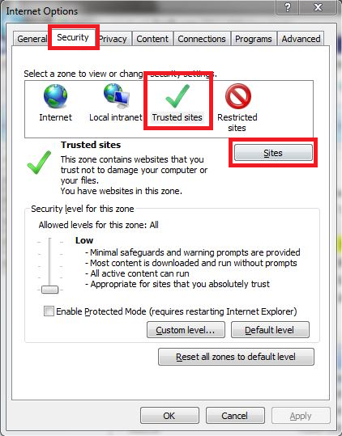
Add your TMS server to your Trusted Sites list twice, once using “http://” and again using “https://” as a prefix. If the “Require server verification (https:) for all sites in this zone” box is checked, you’ll need to uncheck it in order to add the http:// variation of the site.
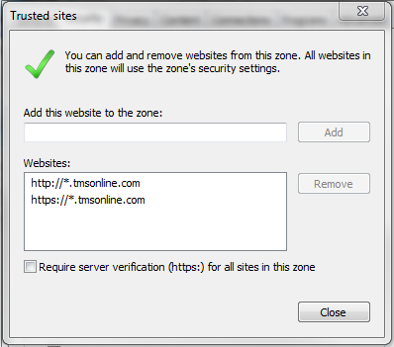
With both sites added, click Close to return to the previous page.
The final step in adjusting your Internet Explorer options is to set the appropriate permissions for Trusted Sites. The easiest way to do this is to set the security level slider to Low for Trusted Sites. It’s important to make sure that you still have Trusted Sites selected when performing this step, or else you will be changing your security level for websites other than your Trusted Sites.
Note: If you already have a Custom security level set for Trusted Sites, the security level slider won’t appear until you click on the “Default level” button.
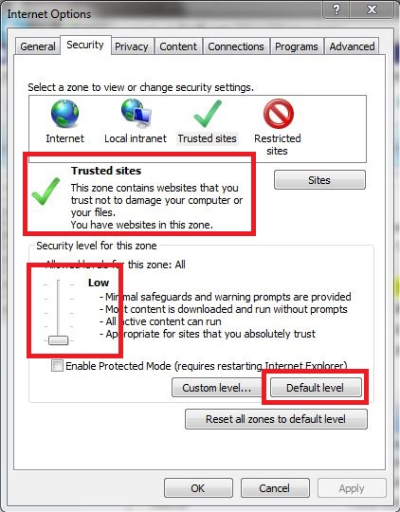
If your IT department will not allow you to use the Low setting, or if you have sites other than TMS listed as Trusted Sites that you’re unsure about using the Low setting for, you can use the “Custom level…” button to specify the individual permissions required by TMS. The individual permissions are:
- .NET Framework
  - Loose XAML (Enable)
  - XAML browser applications (Enable)
  - XPS documents (Enable)
- ActiveX controls and plug-ins
  - Initialize and script ActiveX controls not marked as safe for scripting (Enable)
  - Only allow approved domains to use ActiveX without prompt (Disable)
  - Run ActiveX controls and plug-ins (Enable)
  - Script ActiveX controls marked safe for scripting (Enable)
- Downloads
  - Automatic prompting for file downloads (Enable) – will only show in IE7 and lower
  - File download (Enable)
  - Font download (Enable)
- Miscellaneous
  - Use Pop-up Blocker (Disable)

.NET Framework
Each computer accessing the TMS application must have the Microsoft .NET Framework 4.0 or higher for the application to run.
- Windows Vista/7/8 users should use .NET version 4.5.1
- Windows XP users must use .NET version 4.0 along with this patch

Anti-Virus Active Script Scanning
TMS relies heavily upon scripts when loading pages. If you are experiencing slow speeds while moving between pages, missing data in dropdowns, or values not populating automatically, these problems could be results of script scanning. Please check your anti-virus software and make sure that active script scanning is disabled.

Network Proxy/Firewall Settings (TMS OnLine)
For TMS OnLine customers, network proxies and firewalls must permit inbound and outbound communications from the following IP range and ports for full functionality within TMS:
- 64.58.240.32/27
- 198.51.63.0/24
- TCP/80
- TCP/443
NOTE: Incorrectly configured proxies and web filters can often hinder the use of the TMS application, resulting in slow speeds, intermittent crashes, and other odd application behavior. Sometimes this can occur even when TMS appears to be allowed through the proxy/web filter, requiring a closer examination of the proxy’s or web filter’s configuration settings to enable full application functionality.

Need more help?
If you need further assistance with any of the above steps, or if this guide was unsuccessful in resolving a problem you are having with TMS, please contact our technical support team at frsupport@accruent.com or (412)256-9020.

